Department of Statistics

The Wharton School

University of Pennsylvania

STAT 603 August 2007

Module 2
Finding Structure in Data

Revelation via Statistical Tools

Just looking at raw numbers reveals little, especially for large data sets.

Graphical and numerical statistical summaries narrow focus to essential features of data.

Summarization can be very useful in forming a decision. In order to make use of data, we can often make a better choice if we can summarize the information.

To motivate and illustrate such methods, we’ll study four data sets using JMP.

GMAT Scores (BBS, p. 9)

The analysis of data depends on the nature of your question. Managers have different questions, and so will often need to approach the task differently.

For this example, consider the sorts of questions that might be asked about GMAT scores at Wharton.

Student
Where do I place in the class of Wharton MBA students?

Vice-Dean
How does the entering class compare to those at other programs?
How have scores trended over time?

Effective statistical summaries of data like these can make it easy to answer both types of questions, much more precisely and concisely than from the raw scores themselves.
The first column of the Excel file GMAT05.xls consists of the GMAT test scores of 799 members of the Wharton MBA Class of 2005. That’s one variable with 799 observations, one on each of these students. Let’s open this file with JMP

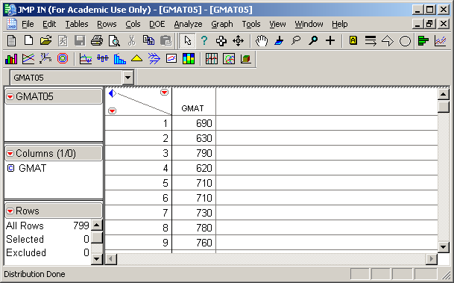

What do you learn by looking directly at this column of 799 numbers?
JMP provides graphical and numerical summaries of the 799 observations of the variable named GMAT.

On the left are two graphical summaries of the data – a boxplot and a histogram. On the right are numerical summaries - various quantiles and moments.

Let’s consider these one at a time and link the numerical summaries to the picture.
Moments

Moments are average quantities of interest.

The mean and standard deviation are the two most basic and commonly used moments.

The mean is the average of the data values for a variable, namely

where we typically use n to stand for the number of values.

From the JMP summary for the GMAT data, the mean =

What aspect of the data is captured by the mean?
The variance is the average squared deviation from the mean. It is calculated as follows:

1. For each observation x, calculate (x - mean), the deviation from the mean of the data

2. Now square each deviation: (x - mean)*(x - mean)

3. Add them and divide by (n - 1)

For the GMAT data, the variance =

What aspect of the data is captured by the variance?

What units ought to be attached to the variance?
The standard deviation (st dev or SD) is the square root of the variance,

From the JMP summary for the GMAT data, the st dev =

What aspect of the data is captured by the standard deviation?

The standard deviation is often more understandable. Why is this so?

Mini-quiz: Which of the following variables will have a larger variance and standard deviation? Why?

-2, -1, 0, 1, 2 or -4, -2, 0, 2, 4

Statistical Notation

Suppose we have n data values of the variable x. We use the notation

to stand for the n data values. The subscript or index shown with the name of the variable, , identifies the ith measurement of the variable.

For example, if we let stand for the GMAT data, then x₁ = , x₂ = ,
x₇₉₉ = , and n =

For any function , summation using this notation (and the Greek Letter Σ) is symbolically abbreviated as

Notation and Formulas for Sample Statistics

The Sample Mean

The Sample Variance

The Sample Standard Deviation

Quantiles

Quantiles are derived from the ordered data values. The k% quantile (also called the k^{th} percentile) is a value that separates the bottom k% of the ordered data from the top.

Quantiles can be used both to capture the location of the data (instead of the mean),
as well as measure the spread of data (instead of the standard deviation).

The most commonly used quantiles
median = percentile
first quartile Q1 = percentile
third quartile Q3 = percentile

Which is a more appropriate measure of the center of data, the mean or the median?

An alternative to the standard deviation as a measure of spread is the Interquartile Range, defined as IQR = Q3 – Q1

What aspect of data is captured by the IQR?
Boxplots

A boxplot is a visual summary of the data based on quantiles. A boxplot makes it easy to relate the quantiles to the histogram.

The main features of a boxplot identify the median, Q1 and Q3.

These are displayed as follows (BBS, p.12)

Remark: JMP calls this an “outlier boxplot”. JMP also provides a “quantile boxplot” which is similar.
Histogram
A histogram is a visual display that reveals the location, dispersion and shape of the data distribution
The basic idea is that the area of each rectangle is proportional to the number of values (frequency) in each interval or bin.
Although programs such as JMP automatically pick a reasonable number of intervals for the histogram, it is sometimes useful to consider an alternative number of intervals.
What is gained and lost by decreasing the number of intervals? Are the modes found in the histogram on the right meaningful, or just artifacts of a subjective choice?

You can learn a lot about a variable by looking at its histogram:

- Center
- The median is the point where half the area is to the left and half to the right.

- The mean is the “balancing point” on the histogram. A piece of wood of constant thickness shaped like the histogram would balance at the mean.

- Shape
- Skewed distributions are asymmetric: the mean will not equal the median.

- If the data is skewed left, then median > mean.

- If the data is skewed right, then the median < mean.
- Modes
Do the histogram have one peak or does it have several?

What does a histogram “hide”, particularly when looking at the variation in a time series such as the returns in Module 1?

When is it OK to hide such details?
Prices of GM Stock (BBS, p. 23)
Question: What is the risk associated with owning a stock like that of GM?
The Excel file GM.xls contains daily closing prices on a share of GM stock. The worksheet GM92 contains 1992-93 data and GM87 contains 1987-88 data.
Let’s use the JMP command Open to select GM92 and study the variable Price.

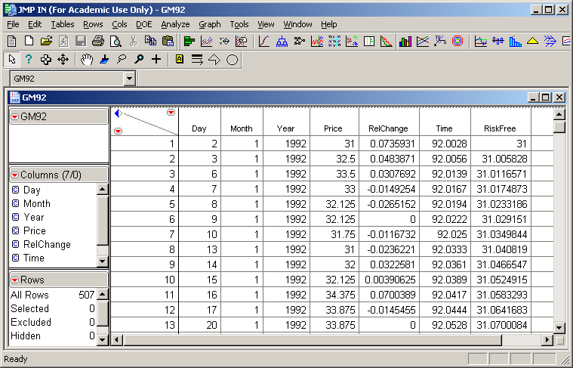
Because the prices form a time series (i.e. a sequence of observations that are ordered in time), we begin with a time series plot (BBS, p. 24-25).
GM Daily Price 1992-93

Note the meandering behavior of this time series. Successive draws do not stray too far from each other.
This is a manifestation of sequential dependence. The price each day depends on the price the previous day.
Does the histogram provide an adequate summary of a variable with this sort of dependence? What does it hide?
A sequence of independent random draws from a population, i.e. a random sample, would not manifest such meandering behavior. The ordering would not affect our understanding of the variance of the data.
To get some insight into what a sequence of independent draws might look like, let’s randomly shuffle the order of Price. A time series plot of Shuffled Price looks like
The sequential variation patterns of Price and Shuffled Price are so different, it is implausible that the Price values are a sequence of independent draws from a population.

Note that both the histogram and summary statistics conceal the meandering behavior.

If you only saw this output, you wouldn’t be able to recover the sequential dependence that is such a dominant feature of the time series plot.
As a summary of the variation, a histogram is misleading. This histogram does not distinguish between a plot of data without patterns like that on page 2-16 (after scrambling the order), and the smooth, meandering patterns seen in the sequence plot of the returns on page 2-15.

Letting p_{t} denote the price of GM at time t, a different perspective is obtained by focusing on the successive daily relative changes or net returns (BBS, p 26-27)

The time series plot of RelChange now looks much more like a sequence of independent draws from a population. The meandering pattern has disappeared.

This is confirmed by the following time series plot of the randomly shuffled values of RelChange.

Note the similarity of the variation patterns of RelChange and Shuffled RelChange.

And since RelChange lacks the sequential dependence seen in Price, the histogram is not hiding much from us.

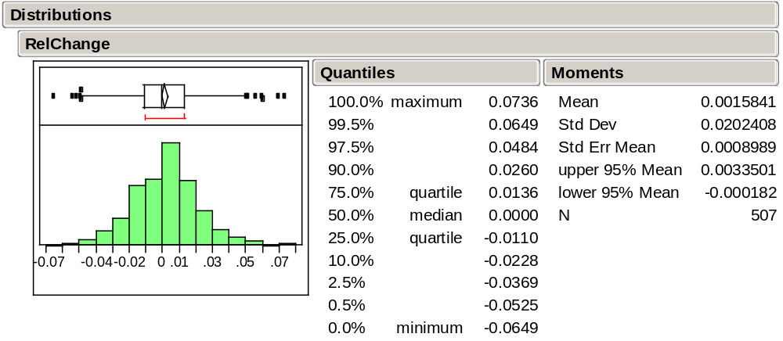

The GM92 histogram shows that the data appears to have a “bell-shaped” distribution in the middle. This is what you would probably see when sampling from a normal population.
This bell-shape is also evident, though perhaps not so clearly, in the histogram of the GMAT scores and many other phenomena as well.

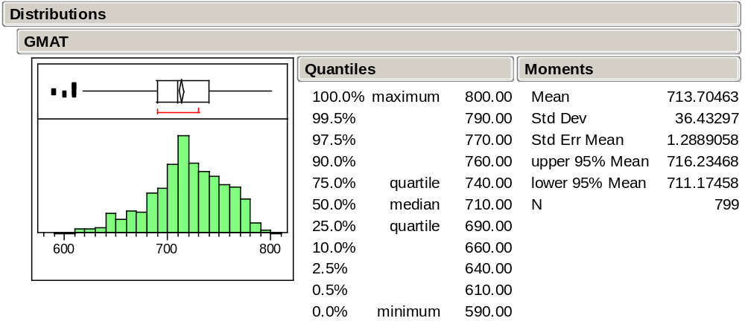
The Normal Distribution

The normal distribution is the ideal “bell-shaped” distribution.

This ideal often approximates the shape of histograms of many data sets that occur naturally

A picture of a normal distribution:

The normal distribution may be thought of as a refined histogram of a very, very large data set.

The mean and standard deviation of a normal distribution are denoted by μ and σ respectively

Important characteristics of a normal distribution are

- Bell-shaped and symmetric about its mean μ

- About 68% (actually .6827) of the area lies within (μ – σ , μ + σ )

- About 95% (actually .9545) of the area lies within (μ – 2σ , μ + 2σ )

- Almost 99.7% (actually .9973) of the area lies within (μ – 3σ , μ + 3σ )

Note that the standard deviation σ is a natural unit of distance for the normal distribution. These values are also tabled in the text, BBS p. 17.

Normality of Data

Using the refined histogram interpretation, the relative area under the curve over an interval can be associated with

The relative frequency of values in the interval
The probability that a randomly drawn observation falls within the interval

Let us see how well the normal distribution approximates the GM92 data. Here, 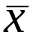 ≈ .00158 and s ≈ .02024 so that

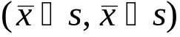 ≈ (-0.0187, 0.0218)

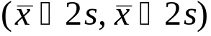 ≈ (-0.0389, 0.0421)

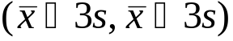 ≈ (-0.0591, 0.0623)

For each of these intervals, it turns out that
366/507 ≈ 72.19% of the observations fall within s of

481/507 ≈ 94.9% of the observations fall within 2s of

504/507 ≈ 99.4% of the observations fall within 3s of
Key point
This approximate agreement between the normal distribution and data is sometimes called the empirical rule. Since the empirical rule seems to hold here, we can concisely summarize the 507 relative changes observed in GM92 with just a mean and SD – the empirical rule translates these two summary statistics into statements about where the values concentrate.

A cool thing about normally distributed data is that the mean and standard deviation summarize all we may need to know about the dataset.

Why this bell-shape and not another?
If the data values arise as the sums of many small random effects, then a histogram of the data will resemble the normal distribution. (The mathematical formalization of this is the Central Limit Theorem (CLT), to be discussed in Module 6).
Normal Quantile Plot
Normality is a powerful assumption; we need a diagnostic to check for normality that works better than just looking at the histogram. Most of our diagnostics come in the form of a plot that requires us to judge how well the data match our assumptions.
To judge if a histogram of data is close to the ideal normal distribution (so that the data can be treated as a sample from a normal population), use a normal quantile plot.

How it works:

If the histogram is close to the ideal normal shape, then all the points will lie between the two dashed lines on either side of the diagonal (BBS, p. 18-19).

What conclusion would you draw about the GM92 data (BBS, p 28)?

Why it works:

The y-axis of the normal quantile plot shows the data.

The x-axis shows the distance from μ in units of σ for the ideal normal quantile associated with each value.

Under this rescaling of the x-axis, a “perfect” normal sample would fall along the straight line y = x.

What causes the small anomaly around 0 in the GM92 normal quantile plot? Did you notice this feature of the data in other plots, or did it only become apparent now?

Forbes Executive Compensation Data (BBS p.34)
Not all data is normally distributed.
The Excel file Forbes94.xls contains the annual executive compensation of 790 executives as reported in the May 23, 1994 issue of Forbes. The JMP summary of TotalComp (total compensation) is obtained as

Someone made $203,020,000! Who was it? (BBS, p.35)
This extreme value dominates the output and makes it difficult to see the rest of the distribution.

Let’s exclude this maximum value and see what happens.

That didn’t seem to help much. A small number of compensations continue to dominate the plot. (BBS p.36-37)

Note, however, that the mean dropped from $2.82 million to $2.57 million and the standard deviation was nearly halved to $4.3 million. The one large salary was very influential upon these summaries.

The size of the effects illustrates how the mean and especially the standard deviation can change dramatically by adding or removing a single point that is far away from the others. The median, in contrast, will not change much.

Let’s remove the next largest 8 salaries and see how things change…

What’s happening?
Transforming the Data
An alternative way of looking at the big picture is to transform the data to a different scale. In this case, let’s consider the log transformation

y = log₁₀ x

If we use base 10, then the logs of the compensations essentially count the number of digits (minus 1, since, for example, log₁₀ 100 = 2 and log₁₀ 1000 = 3.)

Note that log(y/x) = log y – log x so that ratio increases in the original scale correspond to additive increases on the log scale. Thus
changes on a log scale are related to percentage changes.

Question: Which is larger,

[log $11,000 – log $10,000] or [log $1,001,000 – log $1,000,000] ?

For the Forbes data, let’s create the new variable Log10TotalComp = log₁₀ TotalComp
A summary of these logged compensation values:

By transforming, we can see more of the variation among compensation values.

Is any information lost by transforming the data?

Is the average of the logs equal to the log of the average? Given one, can you find the other?
Finding the Sources of Variation (BBS, p.45)

A question of interest: Are executives in some industries more highly paid than those in others? Do we want to find the ‘stars’ or identify industries that pay higher salaries on average?

We’ll use FrbSubt.jmp which restricts the data to a subset of 10 industry categories

Let’s first obtain summaries of the two variables WideIndustry and Log10TotalComp

Goal is to compare compensation among industries.

JMP summaries reveal the variation of each of these variables.

Should we use the “raw” compensation, or use compensation on the log scale? Which question are we trying to answer?

What about the relationship between industry category and total compensation?

Can we tell from these summaries if executives in some industries consistently more highly paid that those in other industries?

Plot Linking
To get some sense of the relationship between them, we can highlight industries such as Financial or Utility. Plot linking in JMP highlights the associated values of Log10TotalComp.
Does it look like Financial or Utility executives are paid differently? Are the differences small, happening just for one or two, or more general?
Comparison Boxplots
Another useful approach for comparison is to look at comparison boxplots.
Boxplots excel when it comes to making visual comparisons.
Comparison boxplots provide a plot that captures differences that we might discover from plot linking in a single, static image.
Each boxplot summarizes compensation within an industry. The plots are shown parallel to each other on the same scale. What can we say about the executive compensation differences across these industries? (BBS, p.48)

Statistics and Variation

In many ways, Statistics can be seen as the study of variation in data.

Basically, we would like to “explain” the variation in data. Why? If we can identify what is causing the data to vary, we might be able to control this variation to our benefit.

At a minimum, we would like to understand why our data vary. The reasons for variation are what we’ll call the “sources of variation.”
Predicting Airline Passenger Demand (BBS, p.50)

A question of interest: How might one go about predicting future demand in a growth industry?

By understanding the variation in demand, we can not only
(a) get a useful prediction of future demand,
we can also
(b) provide a range that indicates the accuracy of our prediction.

The file IntlAir.jmp contains monthly passenger data from 1949 to 1960, a period of rapid growth.

To anticipate demand, let’s use this data to predict the number of passengers in January 1961.

Since this is time series data, we’ll start by looking at a time series plot just as we did with the GM data.

Does the data look like a random sample, or does it show the meandering appearance of dependence?

These data show a complex pattern. How would you describe the variation in the passenger level over time?

What explains the changes in this series?
Here is the summary of the distribution of Passengers

Should we use the mean of about 280,000 per month to predict January 1961, or does this histogram and the accompanying numerical summary hide (ignore) too much?

What would be better?

Working with Relative Changes

Let’s instead look at the successive monthly relative changes, just as we did with the time series that gave prices of GM stock data,

where p_{t} is the value of Passengers in month t.

Here is the corresponding time series plot (BBS, p.52)

along with the summary of the distribution of the relative changes.

What happened to the upward trend?

What happened to the increasing variation?

At first glance, it appears that the mean relative change, about 1.5%, is about the same throughout.

Thus, we might consider predicting the January, 1961 value by
432,000 x 1.015 ≈ 438,000,
where 432 is the December, 1960 value. This prediction is certainly better than the mean of 280,000, but the sequence plot on page 2-41 suggests this estimate will not be very precise.
We can do even better! Let’s highlight the September values (BBS p.52-53)

and then highlight the December values

What’s going on?
Seasonality
A more complete picture of this month-to-month variation, called seasonality, is given by comparison boxplots organized by month (BBS, p.53)
Note that months March, June, July, and December tend to be systematically high and months September through November are systematically low. This seasonal effect drives the replicating pattern that we observed in the original time series plot.
The mean change in January is about 2.6% leading to a more appealing estimate of demand for the next January,
432,000 x 1.026 ≈ 443,000.
How accurate is this prediction?
Take-Away Review

Statistical summaries of data, both graphical (histogram, boxplot) and numerical (mean, standard deviation)

Normality and the shape of a histogram

Characterized by a mean and standard deviation, Use of normal quantile plot

Transforming data to remove skewness

Using statistical methods to understand sources of variation.

Comparison boxplots may reveal underlying sources of variation such as

- Variation due to clustering or grouping.
- Variation determined by systematic effects over time.

Next Module

Probability models for random variation.

Many of the examples that we use in these notes appear with further discussion in the Basic Business Statistics casebook. In some cases, the casebook uses the same data that we consider in class, and in others (like this one), the casebook considers a similar data set.
Open GMAT.xls with the JMP command File > Open (select file type Excel files (*.xls)). By saving this file as GMAT05.JMP, you can then open it by simply clicking on the GMAT05.JMP file.
Use Analyze > Distribution with GMAT selected as the Y column. To get the horizontal layout shown next, right click on GMAT and then Display Options > Horizontal Layout. Note sometimes the histogram won’t initially have contiguous rectangles. To fix this, you need to click on the hand tool (which changes the cursor to look like a hand) and then drag the “hand” downwards on the histogram.
Why are these things called moments? In physics, moments of inertia describe physical properties of an object; where it balances or how hard it is to spin. It turns out that statistical moments capture analogous features of data.
Even though Excel has a built-in formula for the variance, it might be a good idea to work these calculations out directly once or twice to appreciate all of the calculations that the computer software will be doing. Done directly, you’ll need several columns for the calculations.
Why divide by (n - 1) rather than n? An honest answer requires some details that we will not come to until later. For now, just think of the variance as the average squared deviation.
The subscript letter is not always i. For example, the letter t is often used for time series data. Thus x_{t} would be the observed value at time t.
What’s a sample? For now, a sample simply refers to a collection of values. Later on, we’ll define samples and populations more carefully.
Some schools summarize the range of GMAT scores in the form of the 20% and 80% values. That range is almost the Interquartile range, which is just the gap between the 25% score and the 75% score.
In JMP, this can be done interactively with the hand tool.
Remember the connection between statistics and physics? The mean is just the first moment of inertia of the histogram, the balancing point if we think of the histogram as a solid thing sitting on a see-saw.
This time series plot was obtained with the command Graph > Overlay Plot. Select Price as Y and Time as X and right click on Overlay Plot bar to select Y Options > Connect Points.
A more precise characterization of meandering is positive autocorrelation, which we will discuss towards the end of STAT 621. For now, it is most helpful to simply recognize meandering behavior as the data “following itself”, much like a meandering river.
To do this in JMP, select Cols > New Column and name the new variable Shuffled Price. Next select Formula under New Property. In the Formula Editor Window, select Price under Table Columns, select Row>Subscript under Functions, select Random>ColShuffle under Functions and click OK. Again use Overlay Plot to create the time series plot. Note the value of connecting the points in order to see the variation.
Of course, the histogram does hide the timing of the events. But when the observations of a variable are independent, can we really anticipate the timing of the next large value?
When the data is a random sample from a population, the shape of the histogram tends to mimic the shape of the population distribution. (We’ll discuss random sampling in more depth later).
To generate a quantile plot in JMP, you first need to be looking at a histogram. Then use right click on the RelChange bar and select Normal Quantile Plot. Select Fit Distribution > Normal to get the normal overlay curve on the Histogram.
When we open Forbes94.xls with JMP, note that some variables such as TotalComp have numeric values and some have label values such as WideIndustry. JMP denotes the former with a “C” for continuous and the latter with an “N” for Nominal. As we will later see, JMP procedures often treat each of these types in different ways.
To identify points by a variable, highlight the variable’s column and then select Cols > Label/Unlabel. Try it here with the variable CEO and then notice what happens when you point to the extreme value.
To exclude this point, first select it or its corresponding row in the data table. Then select Exclude/Unexclude from the rows menu.
To select more than one point, hold down the shift key when selecting from the graph, or hold down the ctrl key when selecting rows from the data table. Then select Exclude/Unexclude from the rows menu.
This is true for any base.
To do this in JMP, select Cols > New Column, name the new variable Log10TotalComp, and select Formula under New Property. In the Formula Editor Window, select Transcendental functions and then Log10. Select TotalComp under Table Columns and click OK.
Again use Analyze > Distribution. Note that because WideIndustry is a categorical variable (a column with text data that identify groups of observations), JMP automatically provides the summaries in terms of counts and proportions
The plots of the left of these images are bar charts, counting the number of companies in each industry. A bar chart is used to summarize the variation in a categorical variable, such as the one telling us the industry for each CEO. The charts on the right are histograms.
The JMP software shows a bar chart for categorical data such as the industry codes rather than a histogram.
The following plot is obtained using Analyze > Fit Y by X, selecting Log10TotalComp as Y and WideIndustry as X. To show the boxplots, right click on the title bar and select Boxplots under Display Options.
To do this in JMP, use plot linking with Analyze > Distribution on JMP.
This can be obtained using Analyze > Distribution with RelChange selected as Y and Month selected for By.

